Flag Football T-Shirt. Will include name and number on back. Shirt color should not be the same color as the shorts as the manufacturers are different so they may not be identical. Recommend going with a White, Gray or Black shirt if your shorts will be colored. If shorts will be black, then you have more options.
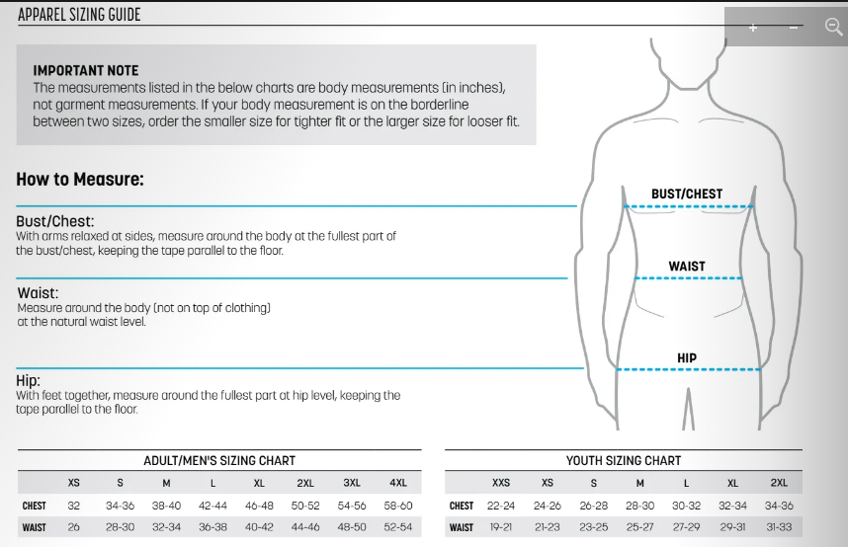

Flag Shorts.
